LEBANESE AMERICAN UNIVERSITY ENGLISH ENTRANCE EXAM
2023– 2024 CYCLE

Thank you for choosing the English Entrance Exam (EEE) at the Lebanese American University. This is a standardized test that will assess your proficiency in the English language in three areas: Reading, Critical Analysis and Writing.
This booklet contains important information that will help you prepare for the test. Please read it carefully.
The Website for the EEE can be accessed on this link: https://www.lau.edu.lb/apply/exams/
We wish you all the best with your application to university.

Table of Contents

Location 3
Schedule 3
Setup of EEE 3
Structure of the EEE 4
User Interface 4
Rubrics of Each Section 5
Results 7
Appendix A 8
Appendix B 9

Location

The EEE is administered electronically using computer laboratories on the campuses of the Lebanese American University.
On the LAU Beirut Campus, the computer laboratories are located in the Adnan Kassar School of Business (AKSOB), Room 1310 and 1311. The campus map in Appendix A shows their location.
On the LAU Byblos Campus, the computer laboratories are located in Frem Civic Center (FCC), Room 106 and in the Medical School. The campus map in Appendix B shows their location.

Schedule

The EEE is administered throughout the year. Applicants wishing to join LAU in the academic year 2023 -2024 can take the test as of October 21, 2023. The schedule for EEE can be accessed on the link: https://www.lau.edu.lb/apply/exams/

Setup of EEE

The EEE is a test that is taken using computers. You will be provided with scratch paper and a pencil during the test period. The notes that you make during the test must be left in the testing room.
They will be shredded by the proctors at the end of the session. You should not bring any books or stationery with you to the test room. You will not be allowed to carry any electronic devices while you are taking the test, these include:
- Smart phones
- Smart Watches
- Bluetooth enabled earphones
- Any other device that is considered “Smart” and can be connected to the internet or make calls.

The proctoring team will ask you to leave your coats, jackets, handbags, backpacks and any electronic devices including mobile phones in a safe place inside the room, but not close to you. You are not allowed to bring consumables into the testing room, this includes:
- Food
- Hot drinks

You may bring a bottle of water into the testing room.
The EEE session lasts two hours. The testing period is 1hour and 40 minutes. We allow 20 minutes for administration. During the entire session you will not be allowed to leave the room. During the entire session you will not be allowed to leave the room. If you experience an emergency which

requires you to stop the test, your session will be terminated and you will be required to re-register for a different session on another day.

Structure of the EEE

The EEE at the Lebanese American University consists of 3 sections:

- Section A is a Reading Test. It includes 2 passages, each followed by a set of multiple choice questions. There are 10 multiple-choice questions. You should complete this section in 20 minutes.

- Section B is a Textual Analysis Test. It includes 3 passages, each followed by a set of multiple choice questions. There are 20 multiple-choice questions. You should complete this section in 40 minutes.

- Section C is a Writing Test. It includes one suggestion for an essay. The topics are of a general nature in the fields of business, history, literature, sciences or the social sciences.
You are encouraged to share your own ideas and opinions, and to illustrate them using references from your own reading, or your personal experience. You are advised to allocate 5 minutes for reading the suggestion and planning your essay. You should complete this section in 35minutes.

User Interface

During the test, your progress will be saved automatically. Once the allotted time for a specific section expires, the test will save and submit your answers automatically. However, if you did not use up all the allotted time, you can save your answers and return to them later.
In section C, you are required to type your essay into a box.

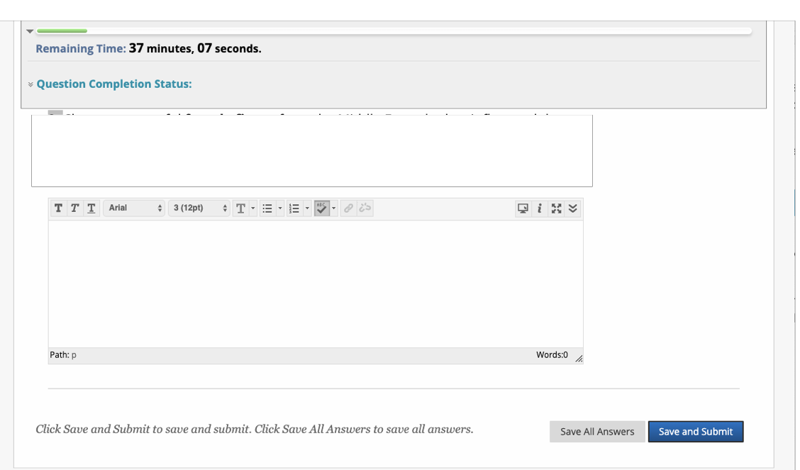

In the upper right corner of the box in blue, you can click on the relevant button to increase the size of the box. You can also click the relevant button to read your submission in full. In the box on the top of the page, you can see the remaining time to complete the test.

Rubrics of Each Section
Description |  | Section A – Reading Test 20 minutes – 10 questions
Instructions |  | Each passage is followed by a number of questions. After reading each passage, choose the best answer to each question based on what is stated or implied in the passage.
Timed Test  Multiple Attempts |  | This test has a time limit of 20 minutes. This test will save and submit automatically when the time expires. The time remaining to complete this test appears at the top of the screen.  Not allowed. This test can only be taken once. Once you click Save and Submit and then OK you cannot return to the test. To review the test click Save Answers and then Cancel
Force Completion |  | This test can be saved and resumed at any point until the allotted time has expired. The timer will continue to run if you leave the test. Your answers are saved automatically.
Description | Section B – Textual Analysis Test 40 minutes – 20 questions
Instructions | Each passage is accompanied by a number of questions. For some questions, you will consider how the passage might be revised to improve the expression of ideas. For other questions, you will consider how the passage might be edited to correct errors in sentence structure, usage or punctuation. Some questions will direct you to an underlined portion of a passage. Other questions will direct you to a location in a passage or ask you to think about the passage as a whole. After reading each passage, choose the answer to each question that most effectively improves the quality of writing in the passage or that makes the passage conform to the conventions of standard written English.
Timed Test | This test has a time limit of 40 minutes. This test will save and submit automatically when the time expires. The time remaining

to complete this test appears at the top of the screen.
Multiple Attempts | Not allowed. This test can only be taken once. Once you click Save and Submit and then OK you cannot return to the test. To review the test click Save Answers and then Cancel
Force completion | This test can be saved and resumed at any point until time has expired. The timer will continue to run if you leave the test.

Description | Section C – Writing Test  35 minutes + 5 minutes of planning
Instructions | Write an essay responding to the suggestion below. You are encouraged to share your own ideas and opinions, and to illustrate them using references from your own reading, or your personal experience.
Multiple Attempts | Not allowed. This test can only be taken once. Once you click Save and Submit and then OK you cannot return to the test. To review the test click Save Answers and then Cancel
Force Completion | This test can be saved and resumed at any point until time has expired. The timer will continue to run if you leave the test.

Rubric for Essay Evaluation

Content
Very Poor | Poor to Fair | Average to Good | Very Good to Excellent
Lacking knowledge of subject, non- substantive, completely off-topic, or not enough to evaluate | Limited knowledge of subject, little substance, partially off-topic, or limited development of topic | Some knowledge of subject, adequate range, average development of thesis, mostly relevant to topic, but lacks substance & support | Knowledgeable, substantive, thorough development of thesis, relevant to assigned topic
Score (13-16) | Score (17-21) | Score (22-26) | Score (27-30)

Organization
Very Poor | Poor to Fair | Average to Good | Very Good to Excellent
Lacking communication, no organization (paragraphing & use of connectors), OR not enough to evaluate | Non- fluent, ideas confused or disconnected, lacks proper paragraphing, logical sequencing and transitioning | Somewhat choppy, loosely organized but main ideas stand out, clear paragraphing, partial logic and sequencing | Fluent expression, ideas clearly stated & linked, succinct, well organized, logical sequencing & cohesion
Score (7-9) | Score (10-13) | Score (14-17) | Score (18-20)

Vocabulary
Very Poor | Poor to Fair | Average to Good | Very Good to Excellent
Essentially translation, little knowledge of English vocabulary, idioms, word from OR not enough to evaluate | Limited & basic range, frequent errors of word/ idiom form, choice, usage, meaning confused or obscured | Adequate range, occasional errors of word/ idiom form, choice, usage but meaning not obscured | Sophisticated range, effective word/ idiom choice and usage, word form mastery, appropriate register
Score (7-9) | Score (10-13) | Score (14-17) | Score (18-20)

Language Use
Very Poor | Poor to Fair | Average to Good | Very Good to Excellent
No mastery of sentence construction rules, dominated by errors, does not communicate, OR not enough to evaluate | Major problems in simple/ complex constructions, frequent errors of negation, agreement tense, number, word order/ function, articles, pronouns prepositions and / or fragments, run-ons,  meaning confused or obscured | Effective but simple construction, minor problems in complex constructions, several errors of agreement, tense, number, word order/ function, articles, pronouns, prepositions but meaning seldom obscured | Effective complex constructions, few errors of agreement, tense, number, word order/ function, articles, pronouns prepositions
Score (5-10) | Score (11-17) | Score (18-21) | Score (22-25)

Mechanics (overlook typos)
Very Poor | Poor to Fair | Average to Good | Very Good to Excellent
No mastery of conventions, dominated by errors of spelling, punctuation, & capitalization, OR not enough to evaluate | Frequent errors of spelling, punctuation, & capitalization, meaning confused or obscured | Occasional errors of spelling, punctuation, & capitalization, but meaning not obscured | Demonstrates mastery of conventions, few errors of spelling, punctuation, & capitalization
Score (2-2) | Score (3-3) | Score (4-4) | Score (5-5)

Upon completing the test, please observe the following steps

- Remain seated until the proctoring team instructs you to leave your seat

- Do not initiate a conversation with anyone in the room

- Do not speak to the proctors
- Do not cause any disturbance to other test-takers

Results

You can access the results under RESULTS section using this link:
https://www.lau.edu.lb/apply/exams/

Appendix A

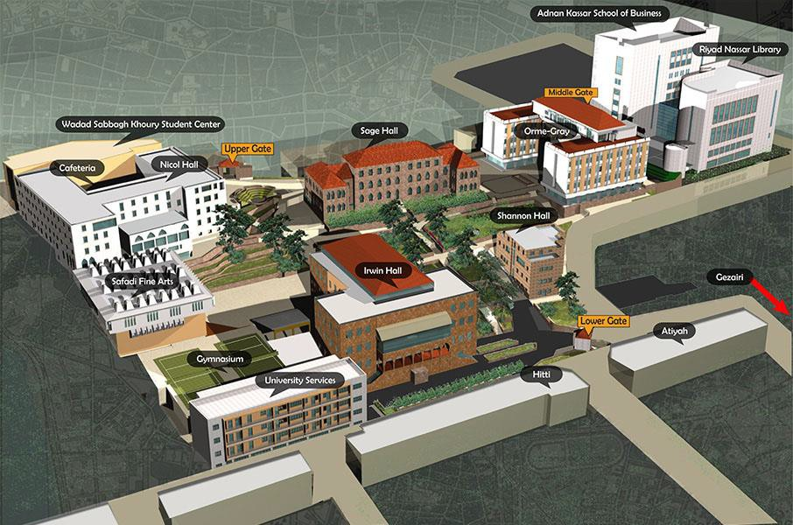

Appendix B

